Work From Home Guide For HRs

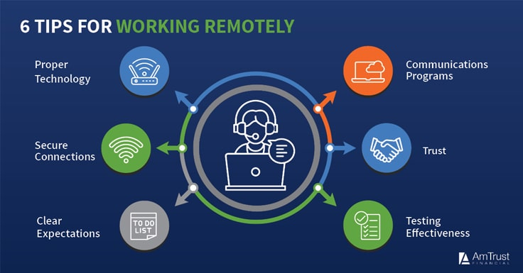

Work From Home Guide
The adoption of remote working on the rise. This is because more companies are embracing the idea to show they care about their employees’ work-life balance. Other factors such as disease outbreaks, natural disasters, etc. have also contributed to the increase in remote work.
In order to stay ahead of this issue, companies have to react proactively by having work from home guidelines in place.
Work from home guidelines outlines everything an employee and a manager needs to do before and during the remote work period. By having a policy in place, you will prevent confusion for your remote workers and managers during your remote working program. 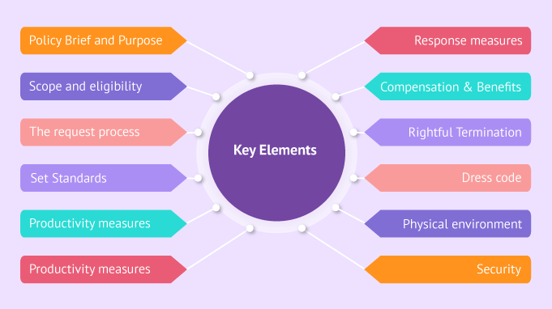

7 Ways Remote HR Can Support Work-From-Home Employees Like A Professional

Use Remote Employee Monitoring Software
HR has the utmost duty to know if the employees are working properly. They do it all the time at the physical office and it’s normal. Things are different for a remote team—managers can’t stay by their side to see how a remote employee works. HR help to fill in this gap. Employees can prove their proactive movements in work It builds trust from all sides and helps increase employee productivity. Businesses need to support their employees’ work by using different software for the team.
Remote work has been in headlines in recent times and that’s for a good reason.remote work grew by 44% in the last five years. The growth in the last 10 years was 91%. Yet, many HR professionals have illusions about developing and handling remote workers spanning the globe. Our list of seven strategies will help remote HR managers to understand and support their employees working from home.

Remain Adaptable to Unknown Situations
The HR manager has to have the willingness to listen and be open-minded to changes. This will help the team to remain productive while working remotely. Implementing new digital solutions Through this, you can get ideas about employees’ important personal events and celebrate their success. Keeping a pulse on the workforce and understanding the changes inside the employees is crucial for proper employee engagement. This way, the HR manager can gradually adopt new policies that reflect the needs and demands of the remote workforce.

Ensure Fair Repay for the Employees
There have been new employment laws in trend over the past few years. These laws require employers to identify the small tasks done by the employees in their devices for organizational benefit. This has made the estimation of employee compensation more difficult and challenging. Employees utilize multiple devices, internet, and office homes for remote work. Employers now have to count on living costs and itemized bill components to make it fair and accurate for each employee. On the other hand, the compensation has to support the organizations’ labor laws as well.

Schedule Virtual Development and Social Events
Professional development events like conferences, and meetups are regularly taking place on virtual platforms. This concept can be used inside remote workforces to establish a wider sense of community and information sharing. Organizations can encourage frequent team meetings or even virtual social hours as an alternative to physical office meetings. let employees interact outside of the normal work discussions and create a sense of teamwork.

Deploy an Employee Engagement App
Employees need motivation when they work from home. They can feel lonely and get frustrated from time to time, as they are staying home by themselves. HR needs to ensure the employees are maintaining a positive mentality and keeping good health for proper job engagement.

Create Benchmarks that Suit Remote Work
Performance evaluation is subjective, so it’s important to get help from the hiring managers to determine individual success. Checking on an employee’s whole day of work is a challenge, and positive results can go unnoticed from time to time. Giving recognition to good work is necessary, so HR needs to make a clear and suitable benchmark. The benchmark should work in a way that can count remote employees’ performances throughout the organization.

Hear Employees’ Thoughts on Remote HR Initiatives


Lastly, allow employees to share their thoughts on remote HR management. Especially in the COVID-19 situation, employee needs to share thoughts on work-from-home polices as it is distinctive from other scenarios. This doesn’t mean remote employees have to frame themselves into the global pandemic time to share opinions. They need to get comfortable in sharing thoughts on remote work policy and HR initiatives for all time. Employees will feel connected to each other and company values when they get to know the value of their voice in the organization.
Remote work is the new normal and using it in business will bring benefits. It is vital to have plans and tools for keeping remote employees connected. This will ensure productivity and safety, help to build company culture for a remote team, and bring employee loyalty.

Work from home guidelines

Policy elements
Employees may work from home:
- Permanently
- Temporarily {Dividing their schedule between being present at the office and working remotely}
Reasons that could demand remote work include but are not limited to:
- Family
- Emergency Issues
- Health reasons
- Work-life balance
(Other reasons for remote work depend on employees’ and managers’ judgment)

Compliance with policies
Remote employees must comply with our company’s policies like their office-based colleagues. These policies include:
Attendance rules: Employees should know how many hours they are expected to work. Let them understand if their stay-at-home attendance is the same as on a regular workday. if not, explain the attendance expectation in detail.
Social media rules: Are employees allowed to post highly opinionated posts about the situation of things? What kind of photos or videos are allowed?
These answers to these questions and every other social media rule that binds them while they work from home should be stated.
Customer & employer confidentiality: Guidelines should be provided to employees on how to protect clients’ information. Other questions like how they should dispose of confidential documents and the kind of information can/can’t disclose should be addressed.

Compensation and benefits
Working from home compensation is determined by job role. Remote work does not affect health insurance and other employment benefits.
Our remote employees will also receive {amount} per month as an allowance to cover office-related costs {e.g. internet, electricity, transport, etc.}

Equipment and tools
Equipment:
For employees to be able to function perfectly outside the office, we will provide our work-from-home employees with equipment that is essential to their job duties such as:
- Laptop or computer
- Company-required software
- Access to corporate emails
- A phone
The equipment we provide is company-owned. To keep it safe and avoid any misuse, employees must:
- Keep their equipment password protected
- Store equipment in a safe space
- Follow all protection standards
- Refrain from downloading suspicious or illegal content
In the event of faulty issues, HR will discuss how to reimburse the employee when applicable.

Tools:
- Human Resource: Having HR management software in place can empower remote employees. HR will allow your employees to access their payroll information and make changes to their personal details all from their home. This could save HR personnel time so they focus on other things.
- Internal Communication: In this section, indicate the method of internal communication during this remote work. This is because, in remote work, emails alone is not enough.
- Collaboration: Explain how employees can work together on a project. This should include a project management app and a video conferencing tool.

